**Subject:** **Mobile Application Design**

Lab 02

Class diagram

**Group members**

Kavitha Vijayan

Sonalben Chauhan

**Android class diagram**

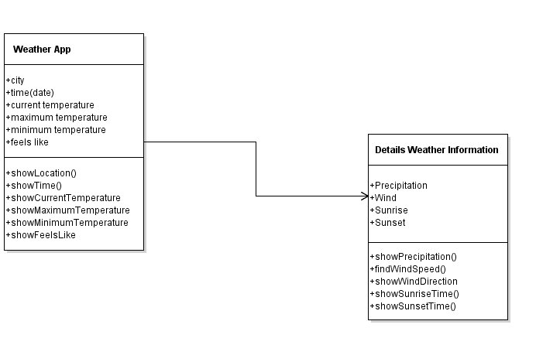

**IOS class diagram**

